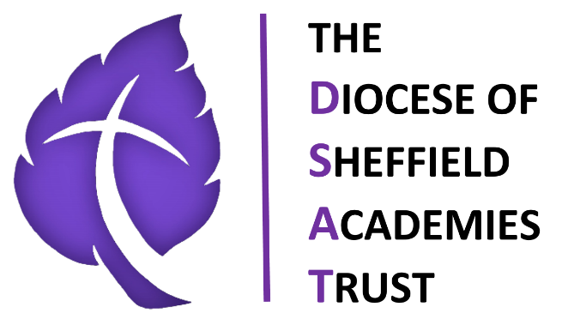

**The Diocese of Sheffield Academies Trust**

**Modern Slavery and Human Trafficking Statement**

**Introduction**

This statement sets out The Diocese of Sheffield Academies Trust actions to understand all potential modern slavery risks related to its activity and to put in place steps that are aimed at ensuring that there is no slavery or human trafficking in its own business and its supply chains. This statement relates to actions and activities during the financial year 1st of September 2024 to 31 August 2025.

As part of the education sector, the organisation recognises that it has a responsibility to take a robust approach to slavery and human trafficking.

The Diocese of Sheffield Academies Trust is absolutely committed to preventing slavery and human trafficking in its mission to deliver exceptional education at the heart of the community, and to ensuring that its supply chains are free from slavery and human trafficking.

We hope that our vision, mission and core values permeate everything we do and are obvious wherever and whenever anyone encounters The Diocese of Sheffield Academies Trust.

**Our Vision:**

* In DSAT, we strive to develop a culture where all are welcome, all are celebrated, all can achieve in inclusive, inspired, and aspirational school communities.

**Our Mission:**

* To create and sustain challenging, stimulating, nurturing and exciting learning experiences, where all children achieve well and are keen to learn.
* To deliver excellence in teaching and learning for all pupils every day.
* To offer an inclusive framework for education that opens for our children “life in all its fullness”.
* To empower leadership at all levels to drive improvements so that each school is aspirational and moves to its next level of performance.

**Our Values:**

We promote Christian values in all we do with a particular emphasis on:

***Respect*** – We believe in upholding high levels of respect for all, where everyone is valued and appreciated. In DSAT, equality and respect for all underpins every decision we make.

***Perseverance*** – We believe that everyone should have the ability and desire to persevere and aim high when things get tough.

***Compassion*** – We believe that compassion, kindness and care are at the core of good human nature and are the basis for successful futures and positive relationships.

***Courage*** – We believe that children should be taught to be brave, to have the strength to be their own person and to ask when they need help, so that all children feel that they are in a safe place to learn and grow.

**Organisational Structure and Supply Chains**

This statement covers the activities of The Diocese of Sheffield Academies Trust:

• We were established in 2014 with a vision to create "Exceptional Education at the Heart

of the Community" and have since grown into a family of 17 Academies.

• We currently serve over 4000 young people, 51% of whom are from disadvantaged

backgrounds and 31% speak English as an additional language.

• We are determined to raise the educational bar for all our students and to close the

educational gap that exists between disadvantaged students and their more privileged

counterparts.

• Our Academies are in three main Local Authorities in England, Sheffield, Doncaster and Rotherham providing primary education.

• Our strong ethos is integral to our educational provision

• We employ over 630 staff, and all of our operations are based in the UK.

**Risk Management**

As part of our initiative to identify and mitigate risk we have identified the principal areas which carry material risks. The Diocese of Sheffield Academies Trust ensures that suppliers are required to demonstrate their methods of corporate social responsibility during the tendering and selection process, details of which may vary according to the project.

**Suppliers to The Diocese of Sheffield Academies Trust**

Suppliers are required to fully comply with the Modern Slavery Act 2015 and are confirming

that they do so by accepting The Diocese of Sheffield Terms and Conditions. The Diocese of Sheffield Academies Trust reserves the right to exclude any bidder who has been convicted of an offence under the Modern Slavery Act 2015.

Additionally, we have in place systems to:

• Identify and assess potential risk areas in our supply chains.

• Mitigate the risk of slavery and human trafficking occurring in our supply chains.

• Protect whistle blowers.

**Procurement and Supply Chain Management**

A considerable proportion of our procurement is with suppliers who are pre-approved either by a purchasing consortium such as Crown Commercial Services (CCS) and Crescent Purchasing Consortium (CPC) or appointed through means of a formal tender process. Our supply chains include:

• education equipment, textbooks, and resources suppliers

• student and staff uniform suppliers

• estate management maintenance and services

• ICT equipment and services

• catering services and supplies

• cleaning services and supplies

• peripatetic music services

• supply/agency staff

We have identified that some of our procurement takes place within sectors where modern

slavery offences could occur, such as within our cleaning and catering supply chains and within the construction industry. We will be taking the following steps to promote awareness of this by:

• Continuing to raise awareness to staff involved in employment, procurement, and management, of the risks of modern slavery occurring within our supply chains.

• Include compliance with the Modern Slavery Act and Living Wage Accreditation as a

condition or criterion in specification and tender documents wherever possible.

• Ensure our supplier on-boarding process includes due diligence around adherence to

the Modern Slavery Act 2015

• Ensure suppliers have access to our standard Terms & Conditions which require

compliance to the Modern Slavery Act

• Look for supplier aggregation opportunities in high-risk areas, such as cleaning, to

better manage the risks associated with Modern Slavery

• Work closely with key partners to better understand how they are managing risks

associated with Modern Slavery

• Consult with our recognised Trade Unions

**Our Policies to Resist Modern Slavery and Human Trafficking**

We have reviewed our existing policies and procedures in light of the Act. We are confident

that our policies promote good behaviour among our colleagues at work and within DSAT. Our policies and procedures are kept under review to make sure that they reflect the changing needs of DSAT and of the staff, pupils, and the communities it serves.

Among the policies that we consider give us strength in avoiding modern slavery or human

trafficking under the Act in DSAT are:

• Staff Code of Conduct

• Equality & Diversity Policy

• EDI Surveys

• Gifts, Hospitality & Related Party Policy

• Safer Recruitment Policy

• Whistleblowing Policy

The whistleblowing policy has been amended to draw attention to the risk of modern slavery

or human trafficking and to stress that a report of concern in relation to those matters can be

made under the protection of the whistleblowing policy.

As an equal opportunities employer, we are committed to creating and ensuring a non-discriminatory and respectful working environment for our staff. We want all our staff to feel confident that they can expose wrongdoing without any risk to themselves.

Our recruitment and people management processes are designed to ensure that all prospective employees are legally entitled to work in the UK and to safeguard employees from any abuse or coercion.

We are determined that there shall be no modern slavery or human trafficking in DSAT. Our policies evidence our commitment to act ethically and with integrity throughout our organisation.

We do not enter into business with any organisation, in the UK or abroad, which knowingly supports or is found to be involved in slavery, servitude and forced or compulsory labour.

All tenders for supply of services and/or goods include a requirement for the supplier to report on their ethical trading including ensuring they also comply with the Modern Slavery Act 2015.

**Training and Continuing Vigilance**

We have discussed the Act, its purpose, and DSATs approach to it at a Board of Directors meeting. We have alerted the Head, Exec Heads and Central Team to it and challenge them to continue to consider where the risk of modern slavery or human trafficking may arise within our organisation. We have provided guidance to our finance team and those involved in procurement of the need to avoid those risks and on possible indicators of them during the procurement of goods and services. We will continue to enhance the assurances we seek from suppliers as to their avoidance of modern slavery and human trafficking.

**Declaration**

This statement has been approved by DSAT Board of Directors and is made pursuant to section 54(1) of the Modern Slavery Act 2015.

.