I can read and write numbers to 10 in numerals and words.

1, 2, 3, 4, 5, 6, 7, 8, 9, 10

Digit

One, two, three, four, five, six, seven, eight, nine, ten

Vocabulary

Practise these a little bit every day.

Practise these walking to school or in the car; maybe you could test your friends at playtime; or even lining up in class.

Top Tips

Practical resources and ideas

* Write a number and ask your child to write the numeral (eg 1-one, three-3).
* Collect a number of objects and ask your child to write how many in numerals and words.

Year 1 – Autumn 1

[Grab your reader’s attention with a great quote from the document or use this space to emphasise a key point. To place this text box anywhere on the page, just drag it.]

Vocabulary

What is 3 **add** 2?

What is 2 **plus** 2?

What is 5 **take away** 2?

What is 1 **less than** 4?

Practise these a little bit every day.

Practise these walking to school or in the car; maybe you could test your friends at playtime; or even lining up in class.

Top Tips

I know number bonds for each number to 6.

Year 1 – Autumn 2

0 + 1 = 1

1 + 0 = 1

0 + 2 = 2

1 + 1 = 2

2 + 0 = 2

0 + 3 = 3

1 + 2 = 3

2 + 1 = 3

3 + 0 = 3

0 + 4 = 4

1 + 3 = 4

2 + 2 = 4

3 + 1 = 4

4 + 0 = 4

0 + 5 = 5

1 + 4 = 5

2 + 3 = 5

3 + 2 = 5

4 + 1 = 5

5 + 0 = 5

0 + 6 = 6

1 + 5 = 6

2 + 4 = 6

3 + 3 = 6

4 + 2 = 6

5 + 1 = 6

6 + 0 = 6

Practical resources and ideas

Use everyday resources – your child has one potato on their plate and you give 3 more – how many do they have now?

Use resources to show different ways of making all the numbers to 6.

Play number bond pairs.

Eg you say 2, what number do you need to make 4?

Vocabulary

What is double 9?

What is half of 6?

Ping Pong – In this game, the parent says ‘Ping’ and the child replies ‘Pong’. Then the parent says a number and the child doubles it. For the harder version, the adult can say ‘Pong’ and the child replies ‘Ping’ then halves the number.

Practise these a little bit every day.

Practise these walking to school or in the car; maybe you could test your friends at playtime; or even lining up in class.

Top Tips

Practical resources and ideas

I know doubles and halves of numbers to 10.

Year 1 – Spring 1

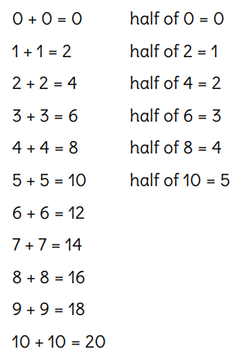

Vocabulary

What is 3 add 2? What is 2 plus 2? What is 5 take away 2? What is 1 less than 4?

Use practical resources – Your child has one potato on their plate and you give them three more. Can they predict how many they will have now?

Make a poster – We use Numicon at school. You can find pictures of the Numicon shapes here: www.bit.ly/NumiconPictures – your child could make a poster showing the different ways of making 6.

Practise these a little bit every day.

Practise these walking to school or in the car; maybe you could test your friends at playtime; or even lining up in class.

Top Tips

Practical resources and ideas

I know number bonds to 10 and number bonds for each number to 10.

Year 1 – Spring 2

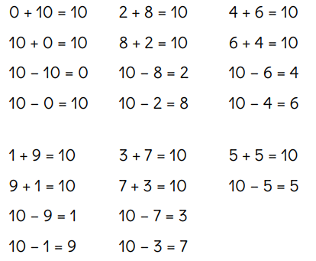

Vocabulary

Practise these a little bit every day.

Practise these walking to school or in the car; maybe you could test your friends at playtime; or even lining up in class.

Top Tips

Practical resources and ideas

I can read and write numbers to 20 in numerals and words.

Year 1 – Summer 1

Practise these a little bit every day.

Practise these walking to school or in the car; maybe you could test your friends at playtime; or even lining up in class.

Top Tips

Practical resources and ideas

Year 1 – Summer 2

I know number bonds to 20.

Vocabulary