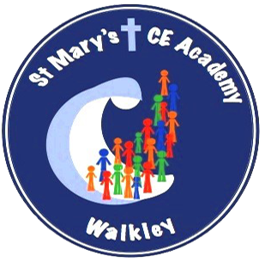
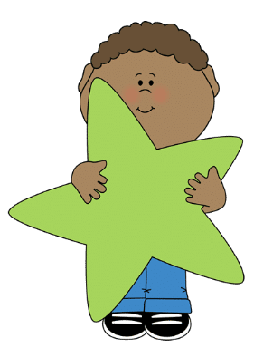
Year 1 Spring Term 2024
What your child will be learning this term:

Writing
Mastery Keys (national curriculum expectations)
- Punctuate sentences using
a capital letter and a full
stop, some question marks
and exclamation marks
- Join words and clauses
using ‘and’
- Some accurate use of the
prefix un-
- Add suffixes where no
change is needed to the
root word e.g. -ed,
-ing, -er, -est

Feature Keys (expectations of the genre)
- Use some story language
- Include and describe new
Characters
- Include and describe the
setting
- Write simple sentences in
sequence (link ideas with
pronouns)
- Include a beginning, middle
and end
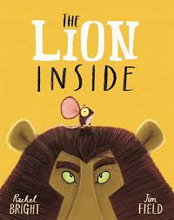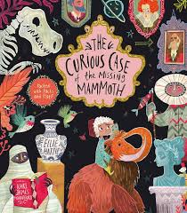

.

Science
Animals, Including Humans
- What is an animal?
- What types of animals are there?
- What types of animals are there?
- What is similar and what is different? What does food tell us about an animal?
- What makes me an animal? What senses do I have?
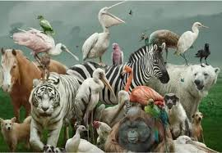

Seasons
- What does Spring look like?
- What does the weather look like for Spring?

Maths
- Place value (within 20)
Counting objects, counting forwards and backwards, one more/one less, comparing and ordering numbers and using a number line.
- Addition and subtraction (within 20)
Number bonds to 20, addition, adding together, adding more; subtraction, taking away, counting back, finding the difference.
- Place value (within 50)
Counting objects, counting forwards and backwards, one more/one less, comparing and ordering numbers and using a hundred grid.
- Length and height
Measuring using a ruler, starting from 0 and comparing heights/lengths.
- Mass and volume
Capacity, volume, comparing capacity/volume, full and empty, heavier/lighter and mass.

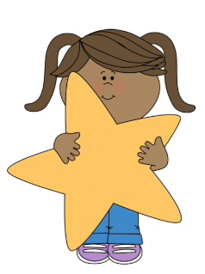

PHSE- A Healthy Me

- Who are my trusted adults?
- What are the Zones of Regulation? How do I keep regulated?
- Where do feelings come from?
- How do I decide what to eat?
- Who is in my family?
- Screen time



RE

Who is Jewish and how do they live?

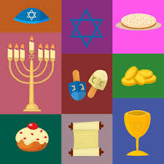

Creative Curriculum
Geography
Hot and cold places

History
What caused the Great Fire of London? How was fire-fighting different in 1666 compared with today?

Music
Dinosaurs
Carnival of the animals

Art/DT
Art – painting
Composition II in Red, Blue and Yellow (1930) by Piet Mondrian
DT – Structures
How can you stop a tower from toppling over?

French
Colours
Numbers to 10



P4C

Philosophy for Children sessions will be taught once a week. The focus of these lessons will change on a weekly basis.

P4C

Philosophy for Children sessions will be taught once a week. The focus of these lessons will change on a weekly basis.

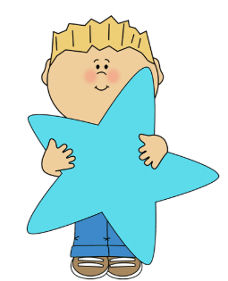
Computing

This term we will be learning how to write and debug algorithms using the software ‘Scratch’.
Computing

Programming A – Moving a robot

Data and information – Grouping data

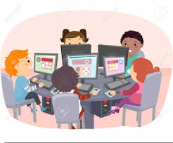

PE

- Fitness

- Sending and receiving

